NAME: RAJA RAYYAN AMEER
REG. NO.: 23-CP-25
SECTION: ALPHA
SUBJECT: DATABASE MANAGEMENT SYSTEM
DEPARTMENT: COMPUTER ENGINEERING
TEACHER: SIR SHAHID
LAB 6
Task 1: Retrieve All Columns from the Books Table.
Query:
SELECT * FROM Books;
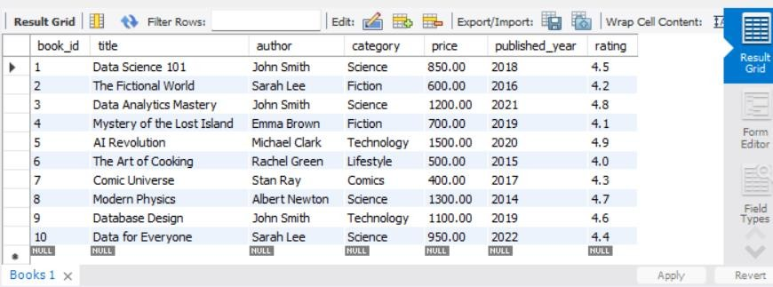
Task 2: Retrieve Specific Columns.
Query:
SELECT title, author FROM Books;
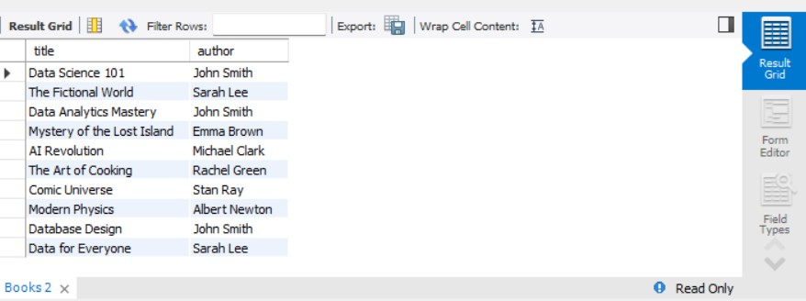
Task 3: Use WHERE to Filter Rows.
Query:
SELECT * FROM Books WHERE category = 'Fiction';
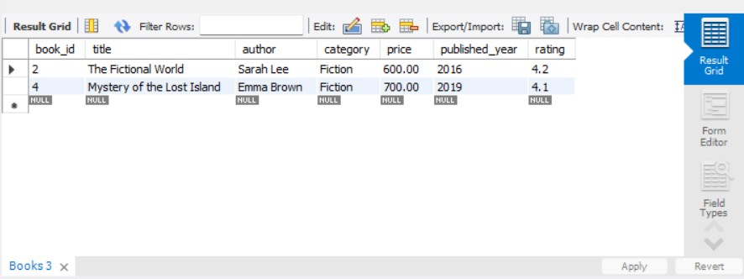
Task 4: Multiple Conditions with AND/OR.
Query:
SELECT * FROM Books
WHERE category = 'Fiction' AND author = 'John Doe';
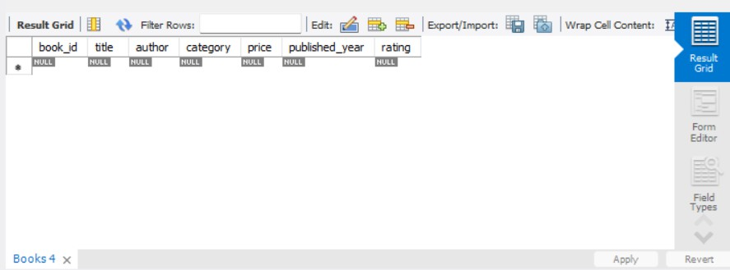
Task 5: Filtering with Comparison Operators.
Query:
SELECT title, price FROM Books WHERE price > 1000;
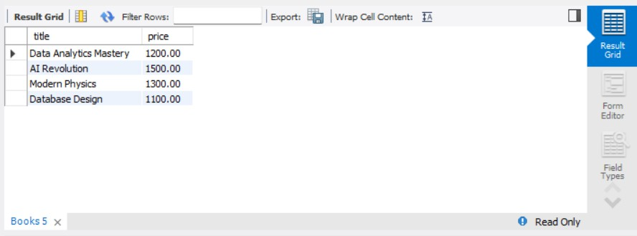
Task 6: Sorting with ORDER BY.
Query:
SELECT title, price
FROM Books
ORDER BY price DESC;
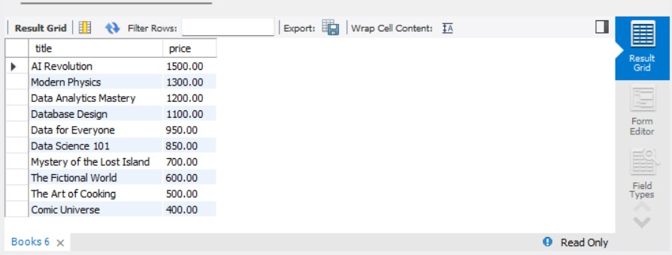
Task 7: Using LIKE for Pattern Matching.
Query:
SELECT * FROM Books WHERE title LIKE 'Data%';
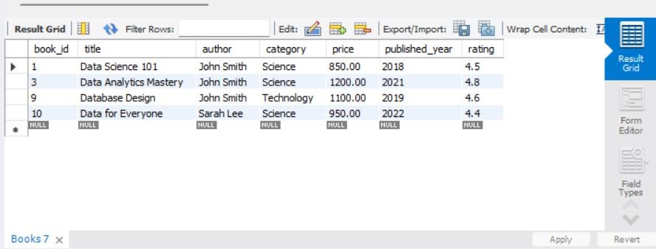

Task 8: Filtering with IN and NOT IN.
Query:
SELECT * FROM Books
WHERE category IN ('Fiction', 'Science');
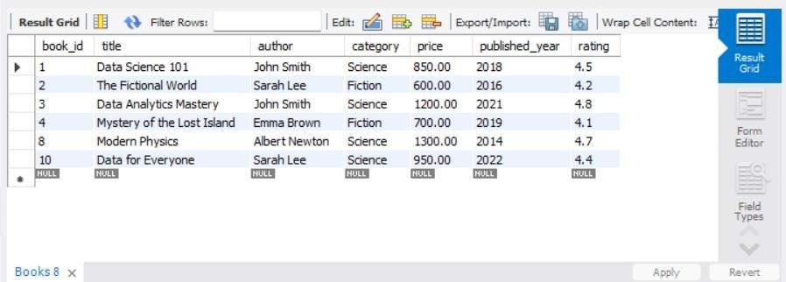
Task 9: Filtering with BETWEEN Clause.
Query:
SELECT * FROM Books
WHERE price BETWEEN 500 AND 1000
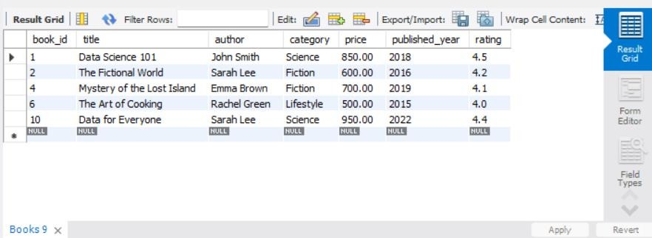
Task 10: Combining WHERE and ORDER BY.
Query:
SELECT title, author
FROM Books
WHERE category = 'Fiction'
ORDER BY title ASC;
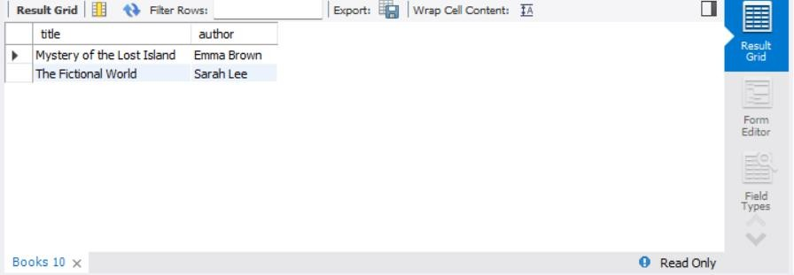
Challenge 1: Find the Top 3 Most Expensive Books. [Retrieve the three books with the highest prices from the Books table.]
Query:
SELECT title, price
FROM Books
ORDER BY price DESC
LIMIT 3;
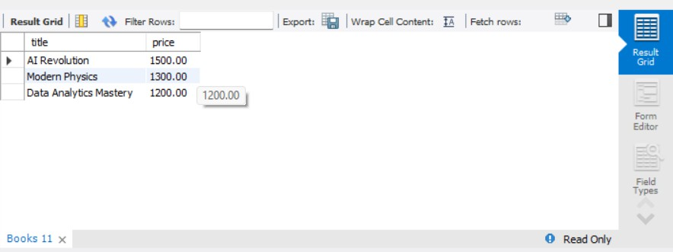
Challenge 2: Retrieve the three books with the highest prices from the Books table. [Display Books with ‘Data’ in the Title, Sorted by Author]
Query:
SELECT * FROM Books
WHERE title LIKE '%Data%'
ORDER BY author;
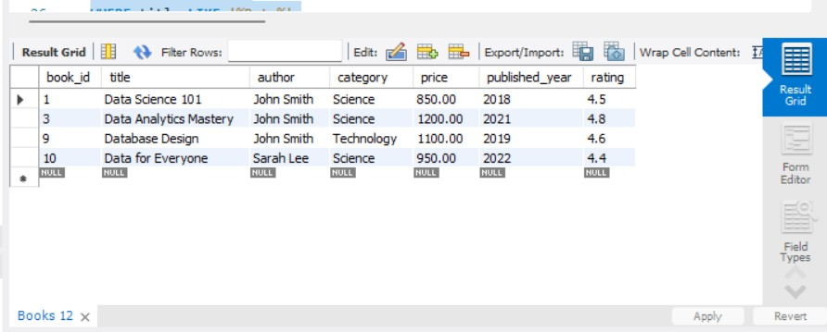

Challenge 3: Retrieve All Books Except ‘Comics’ Category.
Query:
SELECT * FROM Books WHERE category != 'Comics';
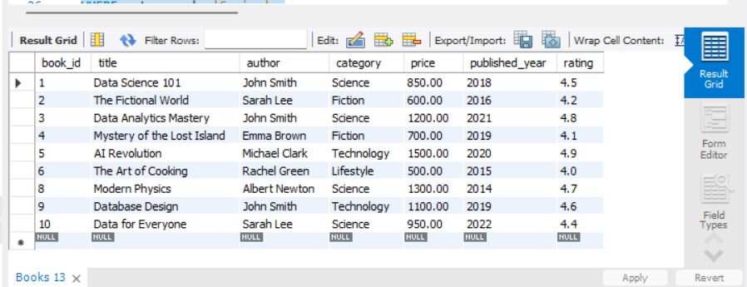
Challenge 4: List All Books Published Between 2015 and 2020. [Retrieve the title, author, and published_year of books published from 2015 to 2020 inclusive.]
Query:
SELECT title, author, published_year
FROM Books
WHERE published_year BETWEEN 2015 AND 2020;
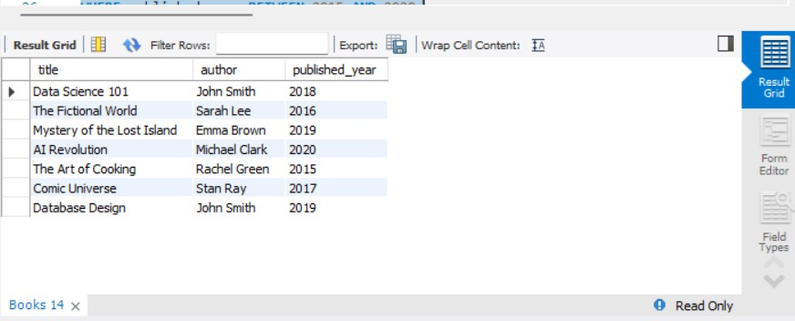
Challenge 5: Find Authors with Multiple Books in the Database. [List all authors who have more than one book in the Books table.]
Query:
SELECT author, COUNT(*) AS book_count
FROM Books
GROUP BY author HAVING COUNT(*) > 1;
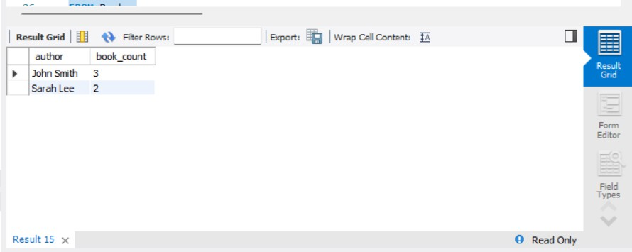
THE END

